**Report on the program B from Assignment 2  
Computer Vision (CS-559)**

**Name: Dhaval Harish Sharma  
Red ID: 824654344**

**Introduction:**This program takes an image as input and produces the histogram of it. Also, it performs histogram equalization to the image and stores its equalised histogram and equalised image in the output.

**Working of the program:**The program starts with importing the necessary libraries for its working. Skimage is used for converting the image to a numpy array as well as displaying the numpy array in the form of an image in the output. Matplotlib is used to plot the histogram of the input image. Initially, the image is taken as input and converted to a numpy array containing the corresponding pixel values. Then, a histogram array is initialized with zeros in order to store the number of pixels in the image according to their respective gray values. We traverse the image pixel by pixel, adding each pixel to the index of its gray level value which gives us the final histogram array. The histogram array is plotted in the form of image in the output. For the second subpart of the question, this whole process is repeated and then an equalised histogram array as well as the output image array is initialised. The normalisation factor is calculated by dividing the number of gray levels in the image by the total number of pixels in the image. After that, the equalised histogram array is formed with the help of the formula which states to add the previous pixel value to the multiplication of the normalisation factor and the histogram array value. Finally, the equalised histogram as well as the equalised image are plotted and saved as the output image.

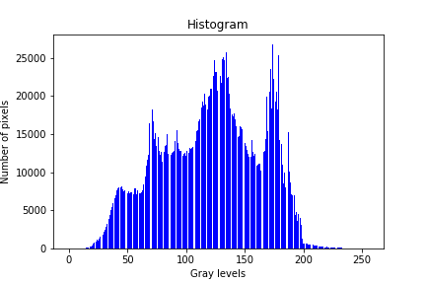 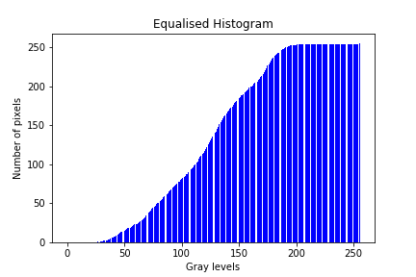

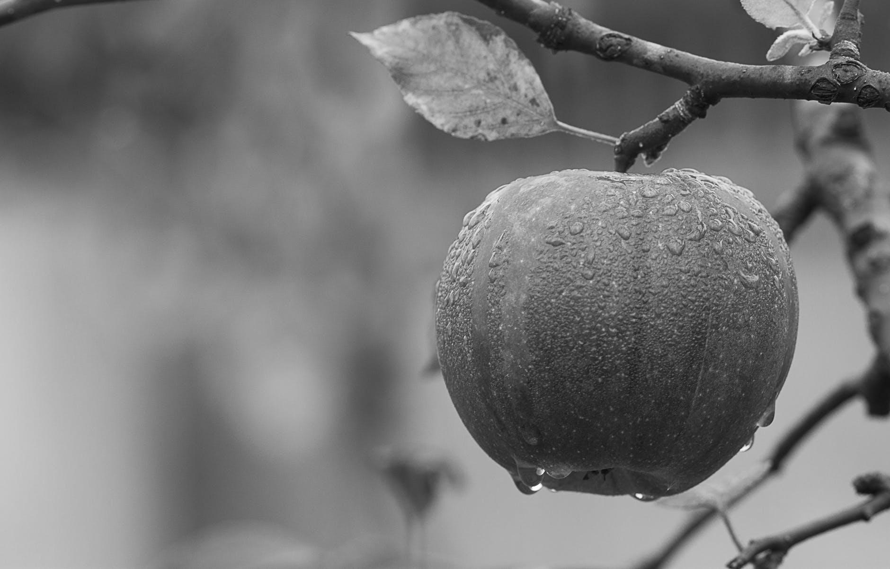 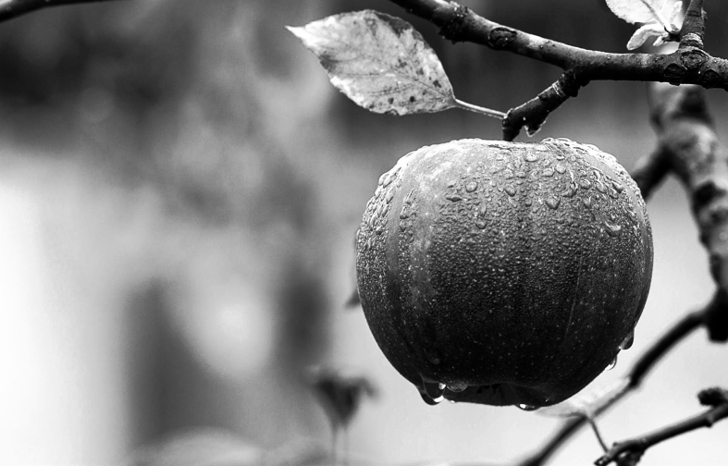  
Original Image Equalised image

Another example of histogram equalised image,

   
Original Image Equalised image

**Findings:**Histogram is a great tool which gives a lot of information about a picture. We can get to know the type of picture by just looking at the histogram, that is, whether it’s dark or light. We can also infer the contrast of the image by looking at its histogram. Note that, two images with same histogram can be visually different. The histogram equalisation can be used to enhance the contrast of the image, which results in a visually appealing image because it tries to maintain the same amount of pixels for all the gray level values. Thus, we can improve the image quality by equalising its histogram.

**Conclusion:**Histogram is a useful property of an image which helps to get an idea about the image and manipulate it. Although, the histogram equalisation is a very basic operation performed on a histogram, it is having several applications in the photography world.